**How to Encrypt an S3 bucket using AWS KMS**

In this task, you will create a customer-managed KMS key and use it to encrypt S3 objects.

1. Navigate to Key Management Service by clicking on **Services** in the AWS Management Console, and selecting **Key Management Service**under **Security, Identity and Compliance** section.
2. Click on **Create a Key**
3. Under configure key:
   * Key type : Select **Symmetric**
   * Key usage : Select **Encrypt and Decrypt**
4. Click on **Next**
5. Under **Add labels:**
   * Alias : Enter ***whiz-kms-key***
   * Description : Enter ***KMS key to encrypt S3 Objects***
6. Click on **Next**
7. Under **Define key administrative permissions:**
   * Key administrators: **Select the role that is associated with the account you are working with**. For example: whizlabs_user-<RANDOM_NUMBER>
8. Click on **Next**
9. Under **Define Key usage permissions:**
   * **Select the role that is associated with the account you are working with.**For whizlabs_user-<RANDOM_NUMBER>
10. Click on **Next**
11. Review everything and click on the **Finish**button.
12. You have successfully created the KMS key.



1. Copy the Key ID and paste it in the notepad, we will use this later in the lab.

**Task 2: Create an S3 bucket**

In this task, you will create an S3 bucket to upload and encrypt an object an aslo to store events.

1. Navigate to S3 by clicking on **Services** in the AWS Management Console, and selecting **S3** under **Storage**section.
2. Click on **Create Bucket**
3. Under **General configuration:**
   * Note: **Bucket name must be a unique name within the global namespace.**
   * Bucket type : **General purpose**
   * Bucket name : Enter ***whizlabs-cloudtrail-kms***

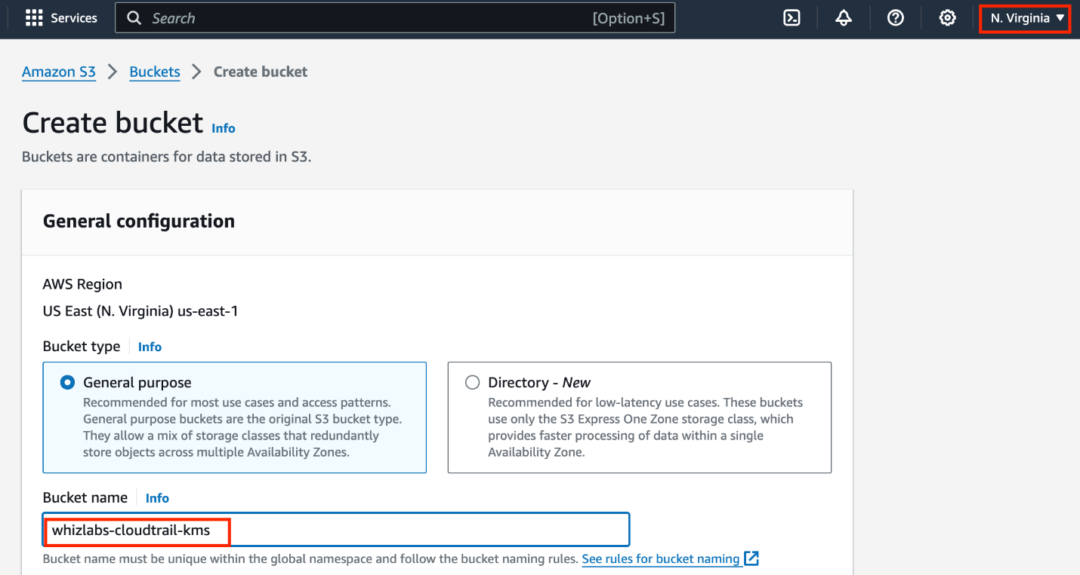

* Object ownership: Select **ACLs enabled** option and choose **Object writer** as the Object owner

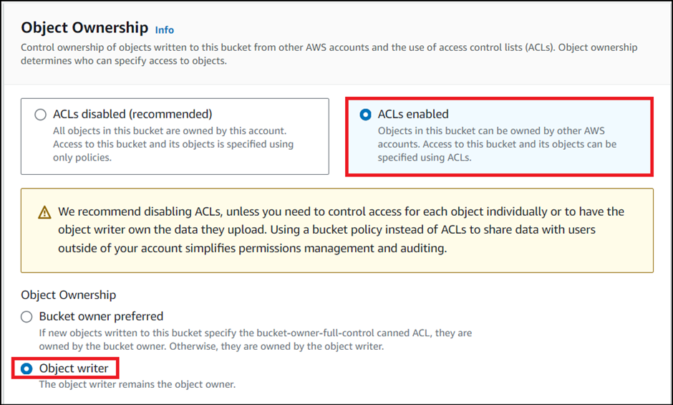

1. Leave the rest as default and click on **Create Bucket.**
2. You have successfully created an S3 bucket.



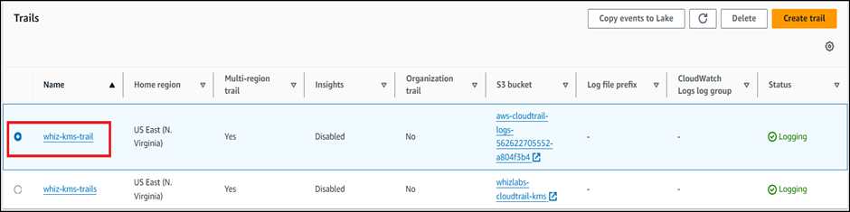

**Task 3: Uploading an object and encrypting it**

In this task, you will upload an image from our local PC and encrypt it using the KMS key we have created in Task 3.

1. Navigate to S3 by clicking on **Services** in the AWS Management Console, and selecting **S3** under the **Storage**section.
2. Click on the S3 bucket **(whizlabs-cloudtrail-kms)** we have created.

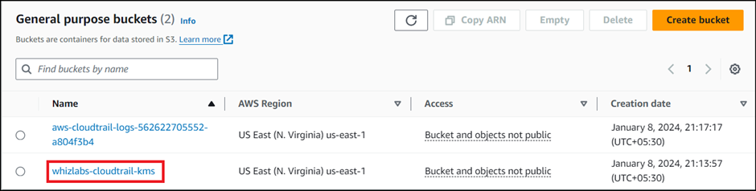

1. Click on the **Upload**button.

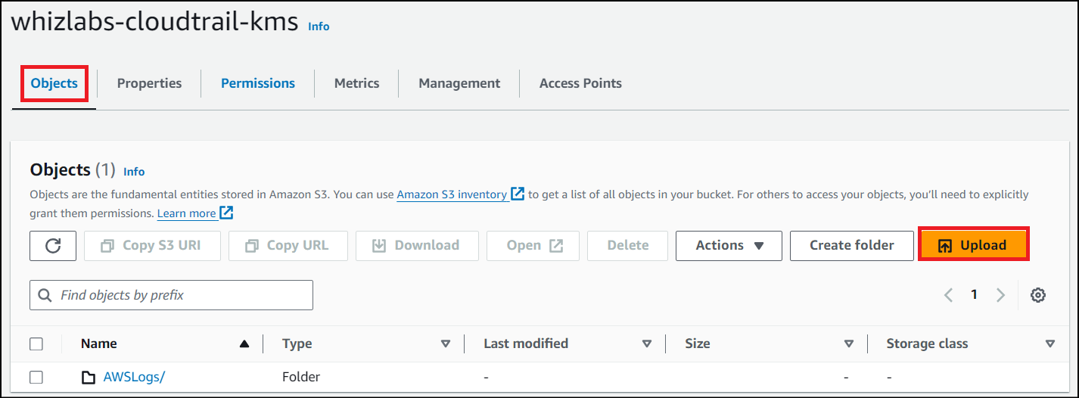

1. Click on **Add files** and choose a picture from your local PC and Click on the **Upload**button.

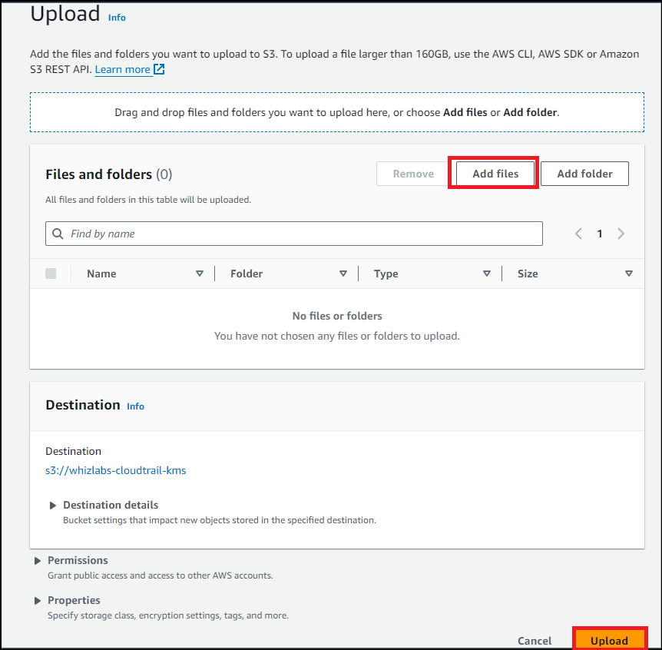

1. Click on the **object** which we have created.
2. Scroll down to **Properties** and click on it to expand.

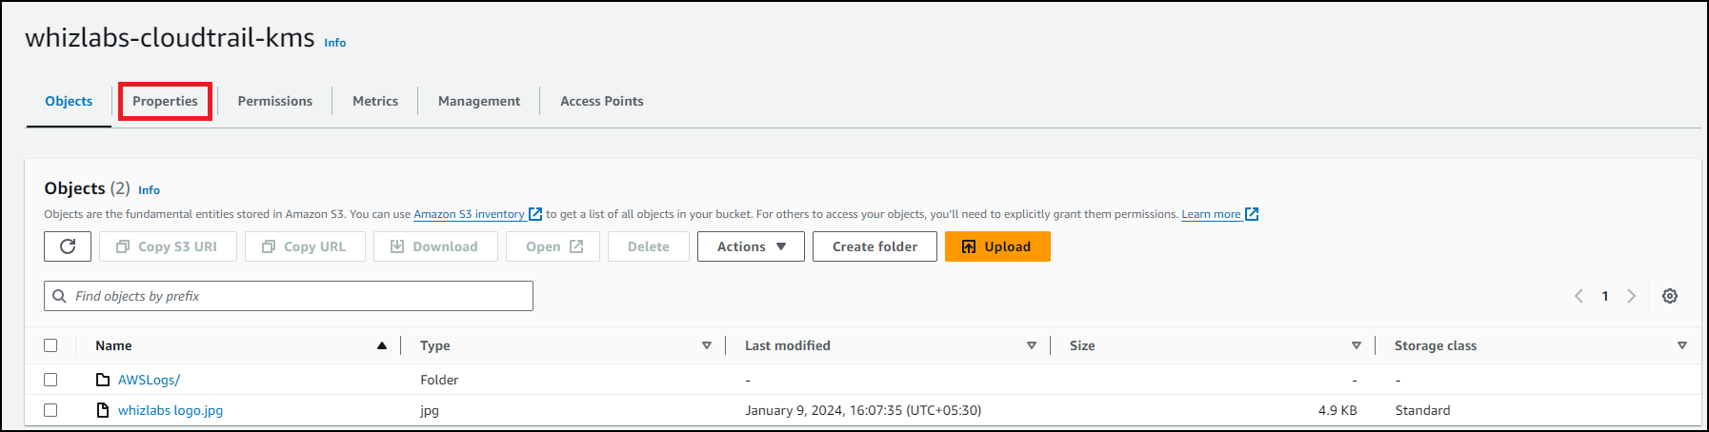

1. Scroll down to **Server-side encryption settings:**
   * Encryption settings : **Override bucket settings for default encryption**
   * Encryption key type : Select **Server Side Encryption with** **AWS Key Management Service key(SSE-KMS)**
   * AWS KMS key : Select **Choose from your AWS KMS keys**and from the drop-down menu select the KMS key we have created i.e **whiz-kms-key**



1. Click on the **Save Changes** button.
2. Click on close and you will see your uploaded picture under the objects section.
3. Note the Last Modified time in the notepad.

**Task 6: Accessing the encrypted object**

In this task, you will try to access the encrypted object through both S3 console and Object URL.

1. Click on the picture you have uploaded and click on **Open** on the top right side of your screen.

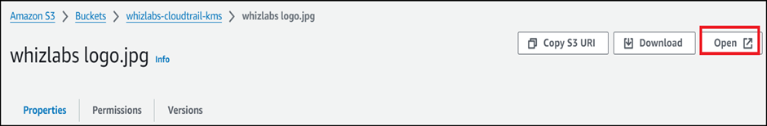

1. The picture opens in a new tab/window.
2. What happens behind the scenes
   * Amazon S3 sends the encrypted data key to AWS KMS.
   * AWS KMS decrypts the key by using the appropriate master key and sends the plaintext key back to Amazon S3.
   * Amazon S3 decrypts the cypher text and removes the plaintext data key from memory as soon as possible.
3. Close the tab/window that displayed your picture.
4. Now copy the **Object URL** and paste it into a new tab of your browser and hit Enter. [In my case : **https://whizlabs-cloudtrail-kms.s3.amazonaws.com/Sharingan.png**]
5. You will see a page with the message “**Access denied**.” And that is because by default, the public access is blocked.

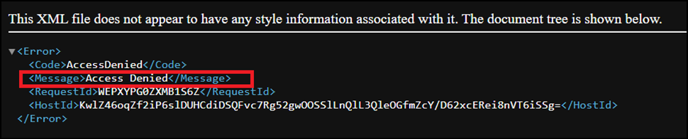

1. Go back to the bucket, click on the **Permissions** section.

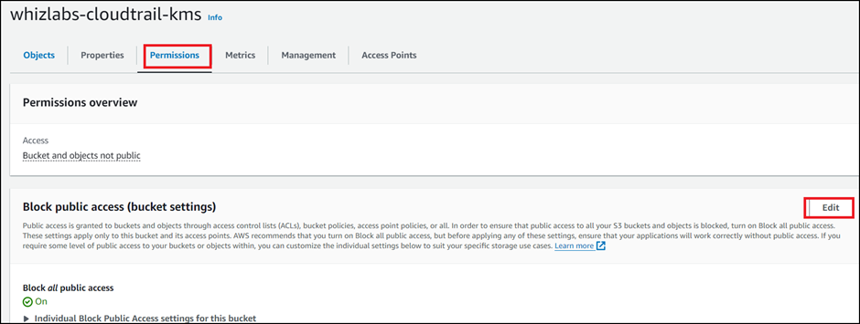

1. Under Block public access, click on **Edit**and uncheck **Block all public access** and click on **Save changes**.
2. In the next screen, Type ***confirm*** and click on **Confirm** button.
3. You have successfully edited Block Public Access settings.
4. Now go to the Objects tab and click on your object.
5. On the top right corner, select **Make public** from the **Object actions** drop-down menu and click on **Make public** **using ACL.**
6. Click on **Make public**button.
7. Now refresh the tab where you have pasted the **Object URL** earlier.
8. You should see a message something like this.

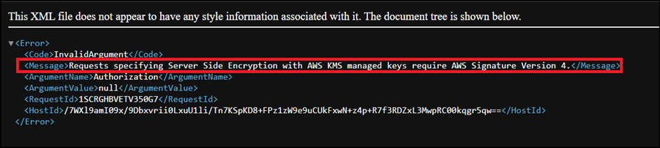

1. This is because the picture is encrypted and you are not able to view it using the public link. If you are uploading or accessing objects encrypted by SSE-KMS, you need to use AWS Signature Version 4 for added security.